Student Name: Weight: 10%
Student ID: Marks: /28

Assignment: Building a Mobile UI with Expo and React Native
This assignment is designed to get you comfortable with working in the expo environment. You will learn how to create a basic React Native project using Expo with TypeScript. You will create a button that triggers an alert when pressed. While some class time will be provided, you should also plan to invest time outside of class. Please see the course schedule and Brightspace for exact due dates. This is a group assignment.
Plagiarism detection software will be used on all student submissions. Please refer to SAIT’s policies and procedures on Student Academic Conduct (A.C.3.4.3) for more information.

Instructions
- Take a snapshot of your favorite mobile app. This might be an Instagram landing page, X feed or a banking app home page. Two sample snapshots are provided below. You can use one of them in this assignment. If you choose your own, the page should be similar in complexity to the sample.
- Create a new, blank –typescript template of Expo. Run: npx create-expo-app@latest .
- Reset the project using npm run reset-project command
- Run the application and modify the index.tsx file to achieve the following;
  - Copy the snapshot of your favorite mobile app in your new application. Try to match the colors, button sizes and other components using the View, Button, Text and any other tag you might need. You do not have to use the same pictures as in the snapshot, just comparable pictures. Use Stylesheet from react-native to style the page. Attempt to match the snapshot at least 80%.
  - None of the copied features such as buttons need to be active or work. The cloning/copying part of the assignment is simply to give practice in using React Native HTML tags and CSS.
  - Add a button at the bottom of the page. Name the button “Alert”. When it is clicked, an Alert should pop up on the page that says “Alert Button pressed”.
- Push the code to a GitHub repository in which all members of the group are collaborators. There must be at least 3 commits in the repo and all members must have contributed. The group might have to demonstrate the code in-person during the in-person class on both android and iOS.
- Submit your GitHub repository link to D2L and make sure the repository has public visibility.

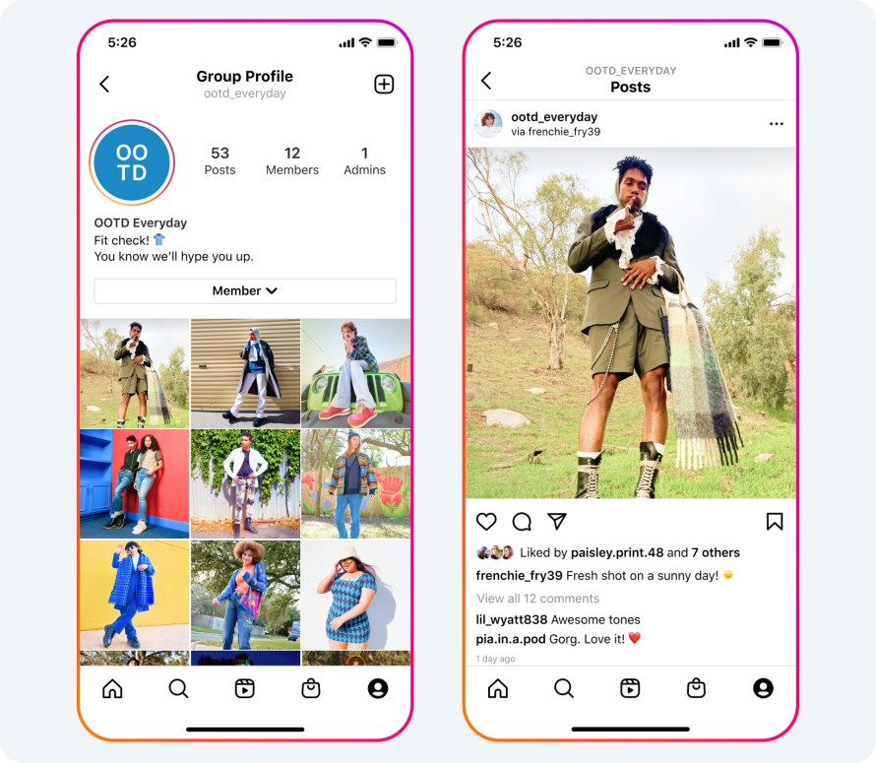
- Only students who have actively contributed code and collaborated through GitHub will be eligible to receive this grade. While one student may submit the final work, the contributions of all group members must be clearly visible and verifiable in the GitHub repository.

Marking Criteria
 | Needs Improvement | Good | Excellent | Marks
Selecting a Suitable Snapshot | There is no Snapshot.  (0 marks) | Snapshot falls short of complexity requirements  (4 marks) | Snapshot is suitable.  (8 marks) | /6
Copy of Snapshot | There is no code demonstrated in class or the code does not work on either iOS or Android.  (0 marks) | There is code demonstrated, but it does not work on either iOS or Android or the work is not suitable.  (5 marks) | The code works on both iOS and Android and it looks at least 80% of the snapshot when demonstrated in class.  (10 marks) | /10
Alert Button | No code or no Alert Button/Action.  (0 marks) | There is code, but it does not work cross-platform or the button does not work.  (2 marks) | The Alert Button works.  (4 marks) | /4
GitHub | No GitHub Link is provided  (0 marks) | GitHub link exists. Repo does not have 3 commits, not all group members contributed.  (4 marks) | GitHub link was submitted. At least 3 commits exist and all group members contributed.  (8 marks) | /8
/28

